Hands-On
Exercise 7: Implementing the Observer Pattern
As part of this module, I successfully implemented, executed, and tested the Observer Pattern in Java by developing a project named ObserverPatternExample. I created a Stock interface with methods to register, deregister, and notify observers, and implemented a StockMarket class that maintained a list of observers and managed stock price updates. I also defined an Observer interface with an update() method and developed concrete observer classes such as MobileApp and WebApp to receive notifications whenever stock prices changed. After completing the implementation, I executed the program and tested the registration, deregistration, and notification mechanisms to verify that all subscribed observers received updates automatically when stock data was modified. This hands-on exercise helped me understand how the Observer Pattern enables efficient one-to-many communication between objects, promotes loose coupling, and ensures that dependent components remain synchronized with changes in the system.
Coding:
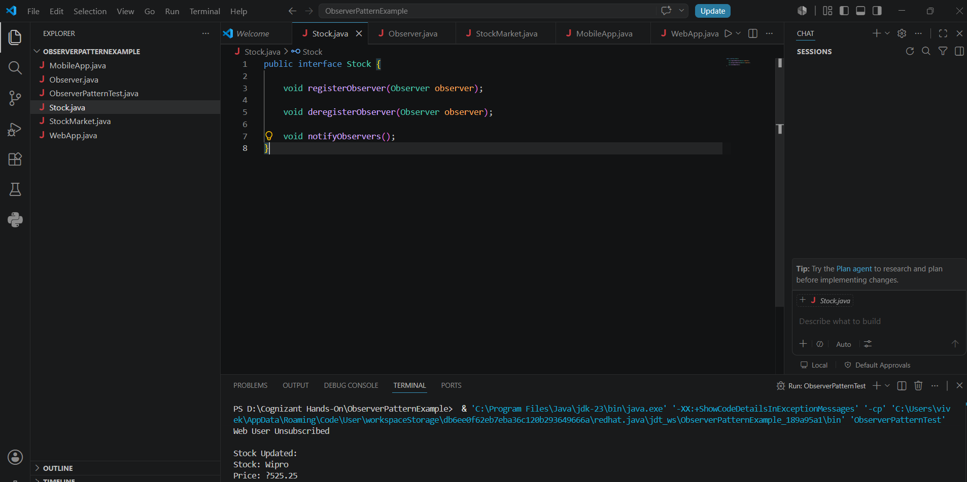
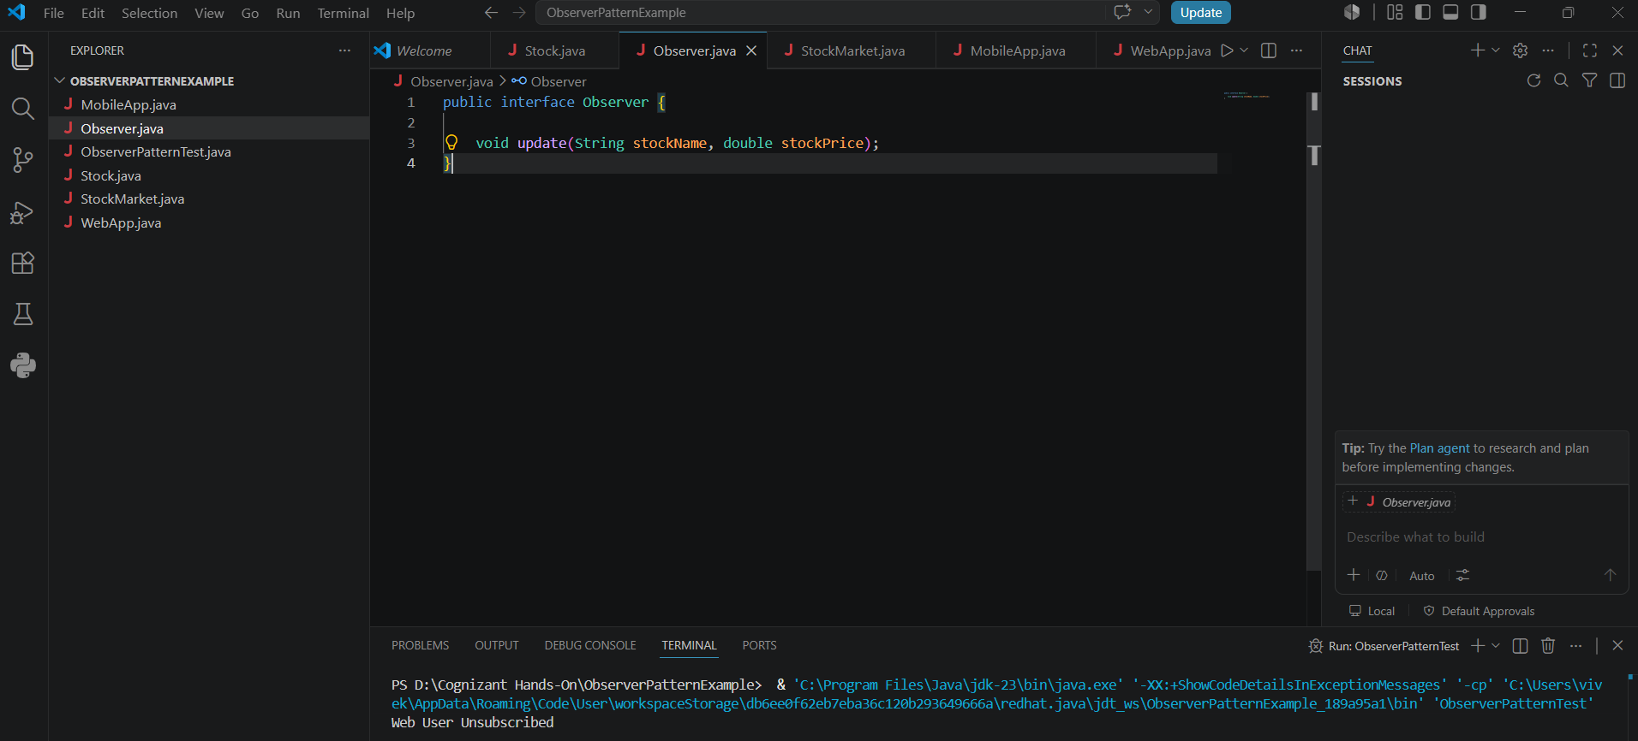

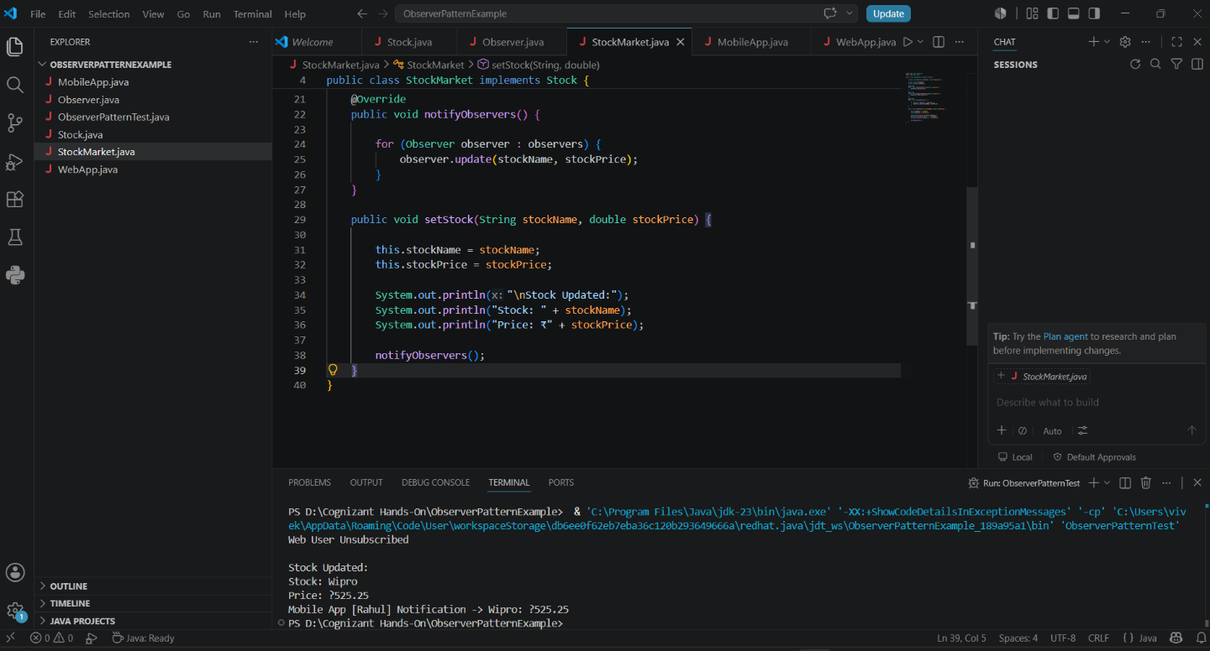

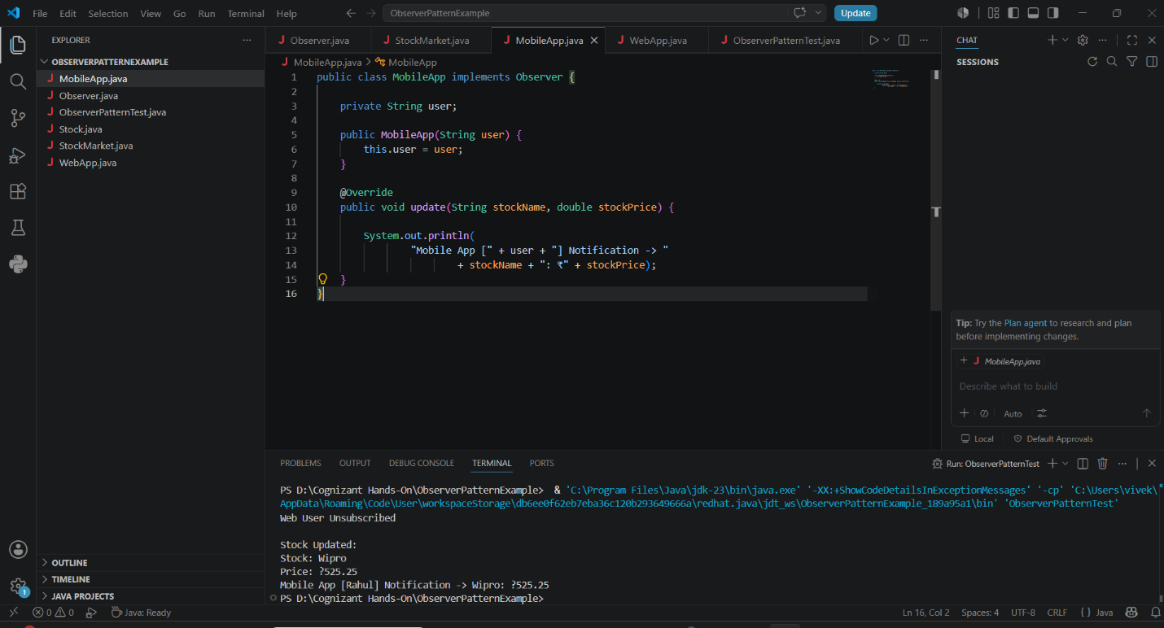
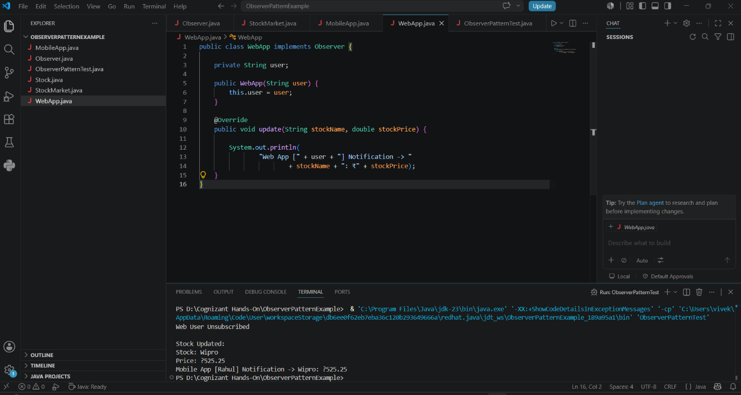
Output:
